Strength and Conditioning
Movement
By British Canoeing & EIS

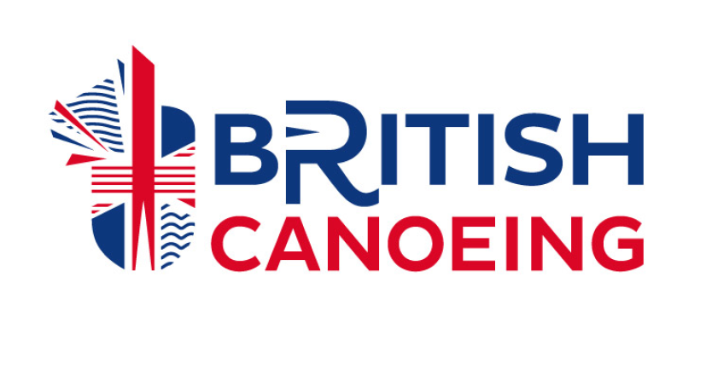

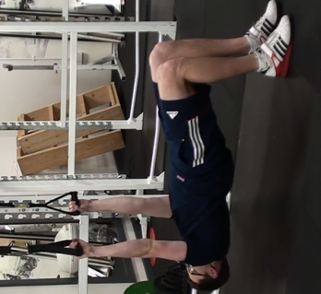
- Supine Row

Gold Standard Position

Start  Position | - Scapular set  - Hands in overhand grip  - Squeeze glute  - Head/shoulders/hips/knees in line  - Knees at 90˚ hips bridged
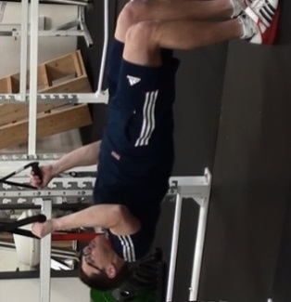
Movement | - Screw shoulders into sockets  - Pull with elbows at 45degrees to body Pull with elbows at 45 degrees to body  - Keep trunk braced and glutes squeezed
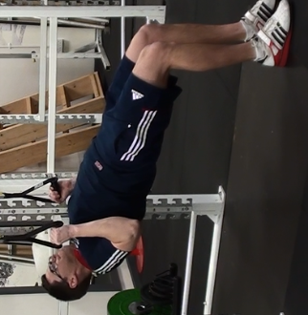
End Range | - Touch chest to bar  - Brace trunk  - Shoulders, hips and knees in line

Common errors
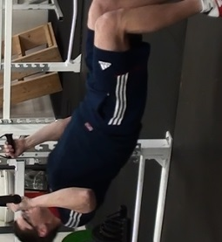
Flexed  Hip | Cue  - Brace trunk  - Squeeze glute  Tip: Coach to put hands on outside of knees to drive against.
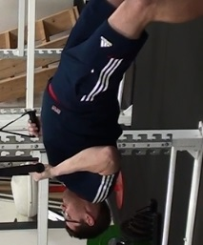

Arched  Back | Cue  - Maintain rib and hip space  - Ensure shoulders, hips and knees inline  Tip: Use an incline to regress the exercise.

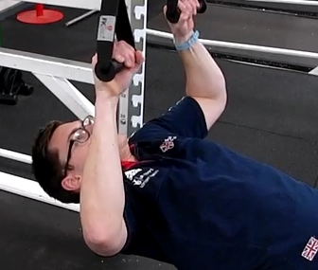
Internally Rotated Shoulers | Cue  - Screw arms into sockets  - Pull the bar apart  Tip: Use rings or suspension kits to put shoulders in a neutral position.

- Press Up

Gold Standard Position
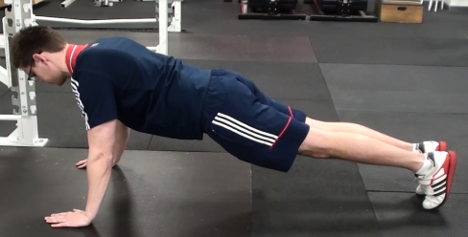
Start  Position | - Hands thumbs width away from shoulder  - Directly under shoulder  - Head, shoulder, hips and knees in line  - Trunk braced  - Feet hip width apart
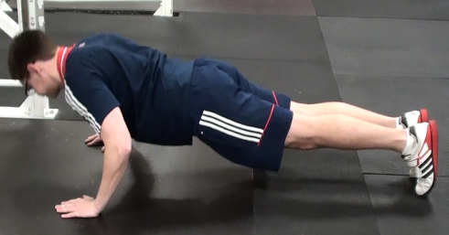
Movement | - Screw arms into sockets  - Maintain rib and hip space  - Lower body maintaining shoulder, hip , knee alignment  - Bend at the elbow

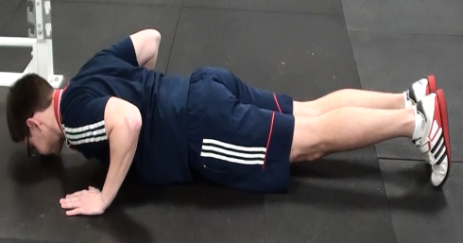
End  Range | - Chests touches floor  - Elbows at 45° to body  - Elbows pointing towards the ceiling

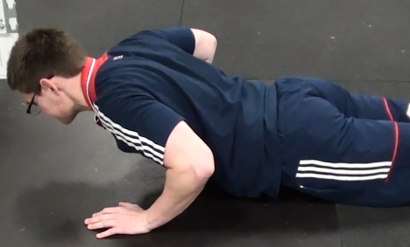
Common Errors
Arched  Back | Cue  - Tuck ribs in. Maintain space between rib and hip.  - Hips up, ensure shoulders, hips and knees inline.  Tip: Incline the press up to regress the exercise and ensure full range of movement while maintaining form.
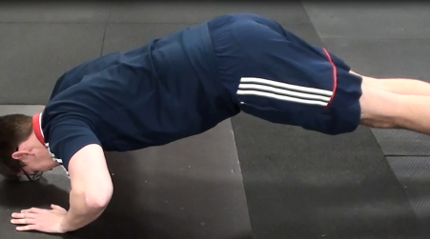
High  Hip | Cue  - Brace trunk  Tip: Place broomstick on back to ensure shoulder and hip alignment.
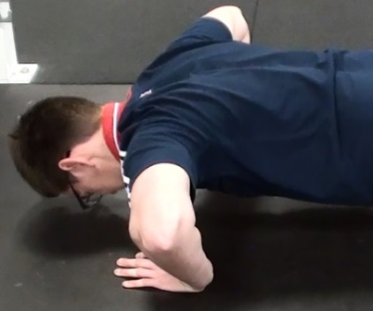
Internally Rotated Shoulders | Cue  - Keep elbows close to body  - Screw shoulders into sockets

- Chins

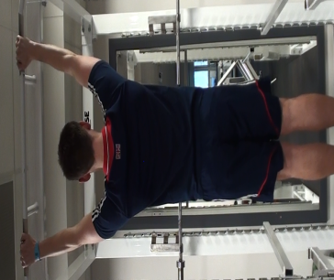
Gold Standard

Start  Position | - Hands just outside shoulder width, neutral grip  - Start from full hang position, body and legs straight  - Ensure there is no swing or momentum before initial movement

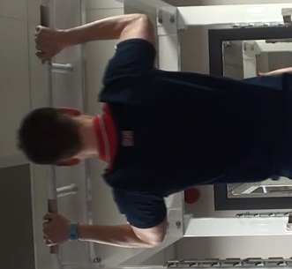
Movement | - Brace trunk and squeeze glute  - Chin tucked in and neutral spine  - Engage lats to begin pull
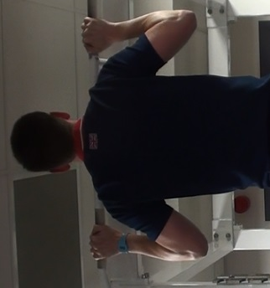

End  Range | - Chin beached on top of bar  - Elbows in towards body  - Shoulder, trunk, hip in a straight line

Common Errors
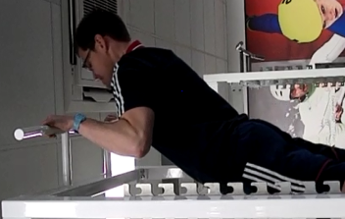

Trap Dominance | Cue  - Create space between ears and shoulders  Tip: Use bands arounds knee/feet to assist

Arched  Back | Cue  - Tuck ribs towards hips  - Brace trunk
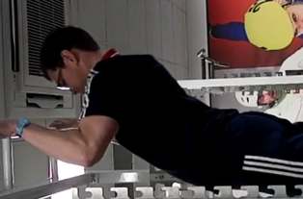
Leg Kick | Cue  - Insure a dead hang before initiating movement  Tip: Place object in front of athlete to create physical barrier

- Pull Over

Gold Standard Position
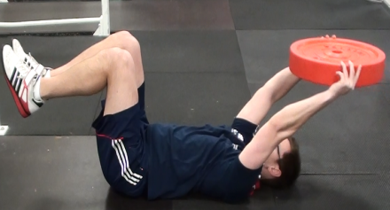
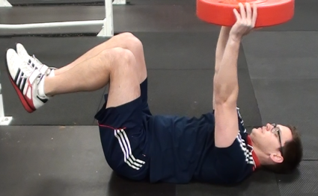
Start  Position | - Lying supine on the floor  - Knee and hip flexed to 90˚  - Neutral spine  - Arms perpendicular with the floor  - Scapular set  - Create as much space between shoulder and

Movement | - Screw arms into shoudler sockets  - Flex at the shoudler moving arms overhead  - Arms long and straight

End  Range | - Arms Parallel to the floor  - Arms extended  - Neutral spine
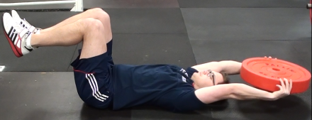

Common Errors
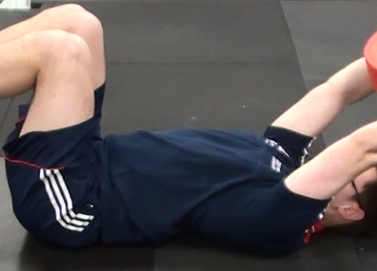
Arched Back | Cue  - Pull ribs into hip  - Brace Trunk  Tip: Place hand under back to maintain pressure from neutral spine. Lower weight.
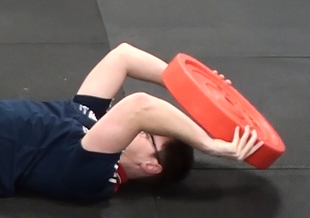
Bent  Arms | Cue  - Ensure elbows are extended  - Long Arms  Tip: Place a target/ hand for athlete to aim for
Shoulder Hitch | Cue  - Maintain space between shoulders and ears  - Pull shoulder towards hips

- Bent Over Row
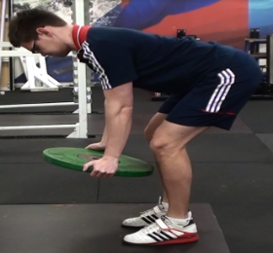
Gold Standard Position

Start  Position | - Knees Flexed and soft  - Torso just above parallel to the floor  - Hinge at the hip  - Head, shoulder and hips in line
Movement | - Pull With Elbows at 45˚ to body  - Keep chin tucked in  - Maintain torse position just above parallel to the floor  - Pull shoulders down
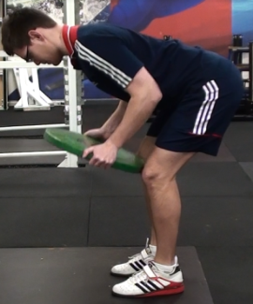
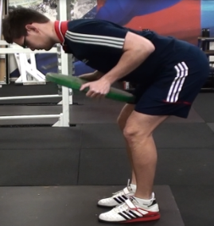

End  Range | - Weight touches bottom of sternum  - Elbows pointing upwards  - Neutral spine  - Soft knees

Common Errors
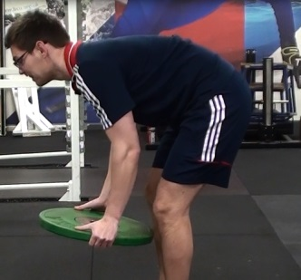
Rounded  Back | Cue  - Stick ‘tail’ out  - Chest up- show logo on t-shirt  Tip: Place broom stick along line of spine

Upright  Row | Cue  - Ensure RDL position is achieved  - Keep torso just above parallel to floor  Tip: Place forehead on incline bench
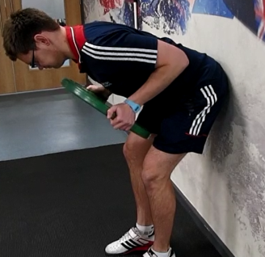
Leg  Drive | Cue  - Lower weight  - Ensure knees are maintained soft  - Maintain torso position  Tip: Perform movement against wall

Common errors
Split Squat

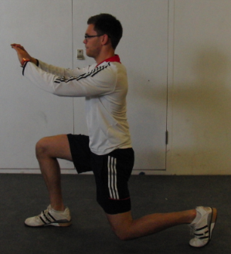
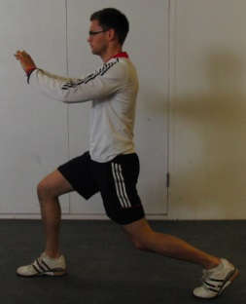
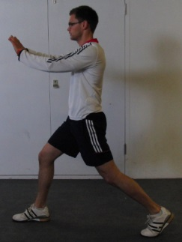
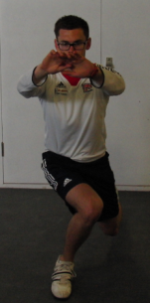
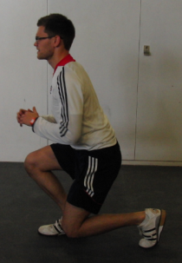
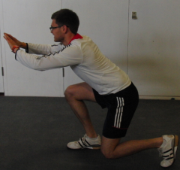
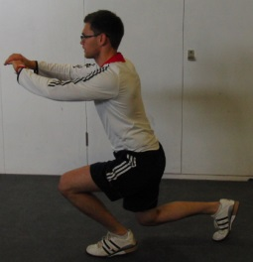
Set up
- Feet hip width apart
- Both feet and hips facing forwards
- Neutral spine
- Both knees at 90°
Movement
- Front shin perpendicular to the ground
- Front knee tracking along the line of the toes
- Trunk braced
- Drop back to towards the ground
Bottom Position
- Both knees at 90°
- Front thigh parallel to the ground
- Head and chest up
- Weight in heal of front foot
Cue
- Chest up
- Brace trunk
Tip: Start in the bottom position and reverse the movement.
Cue
- Ensure 90degrees in both legs
Cue
- Sit into hip dropping back knee to the ground
Tip: Put stick in front of knee to ensure knee does not track over toes.
Cue
- Drive knees out
- Screw hips into sockets
Tip: Coach to put hands on outside of knees to drive against.

Squat
Gold Standard Position
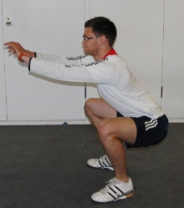
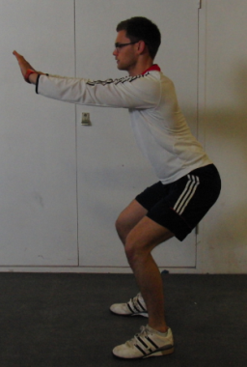
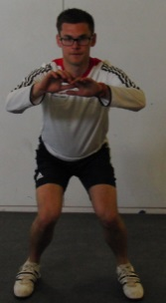
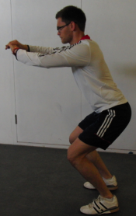
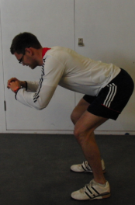
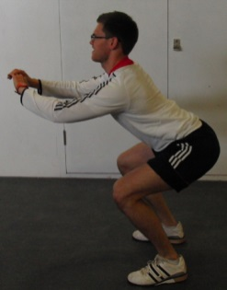
Set up
- Feet shoulder width apart
- Toes at 11 and 1 o’clock
- Knees track along line of toes
- Neutral spine throughout the lift
- Chest and head up
- Trunk braced
Movement
- Sit the hips back transferring weight to heels
- Knees and hips bend at the same time
- Trunk braced
- Knees to track along the line of the toes
Bottom Position
- Knees to track the line of the toes
- Chest lifted and head up
- Trunk braced
- Weight sitting through the heels
- Top of thighs parallel with the floor
Cue
- Drive knees out
- Screw hips into sockets
Tip: Coach to put hands on outside of knees to drive against.
Cue
- Sit back into hips
- Sit on a chair
Tip: Use box to reach towards with hips.
Cue
- Chest up
Tip: Perform a balance squat holding onto partner to ensure trunk alignment.
Cue
- Chest up
- Maintain space between ribs and hips
Tip: Imagine you have a tail; tuck the tail between your legs.

