Membership No.:
Name:

BCAB Coaching, Leadership and Guiding

Contents

This logbook is designed so you can record your experience as well as reflect on learning that has taken place and areas you may wish to develop. Keeping a diary does help you realise and celebrate your progression. Whilst these records are not essential for any British Canoeing Awarding Body qualification or award, you can choose to share this information with your mentor in aiding your development, as well as using to evidence currency as part of the British Canoeing Awarding BodyCoach and Leadership Update Scheme.
This logbook is designed for you to record your:
- Paddling experience
- Leading trips, journeys and expeditions
- Instructing and coaching
- Leading or guiding trips, etc.
Other records such as qualifications, training attended, first aid and safeguarding can be found within your own unique membership digital record in the National Association database.
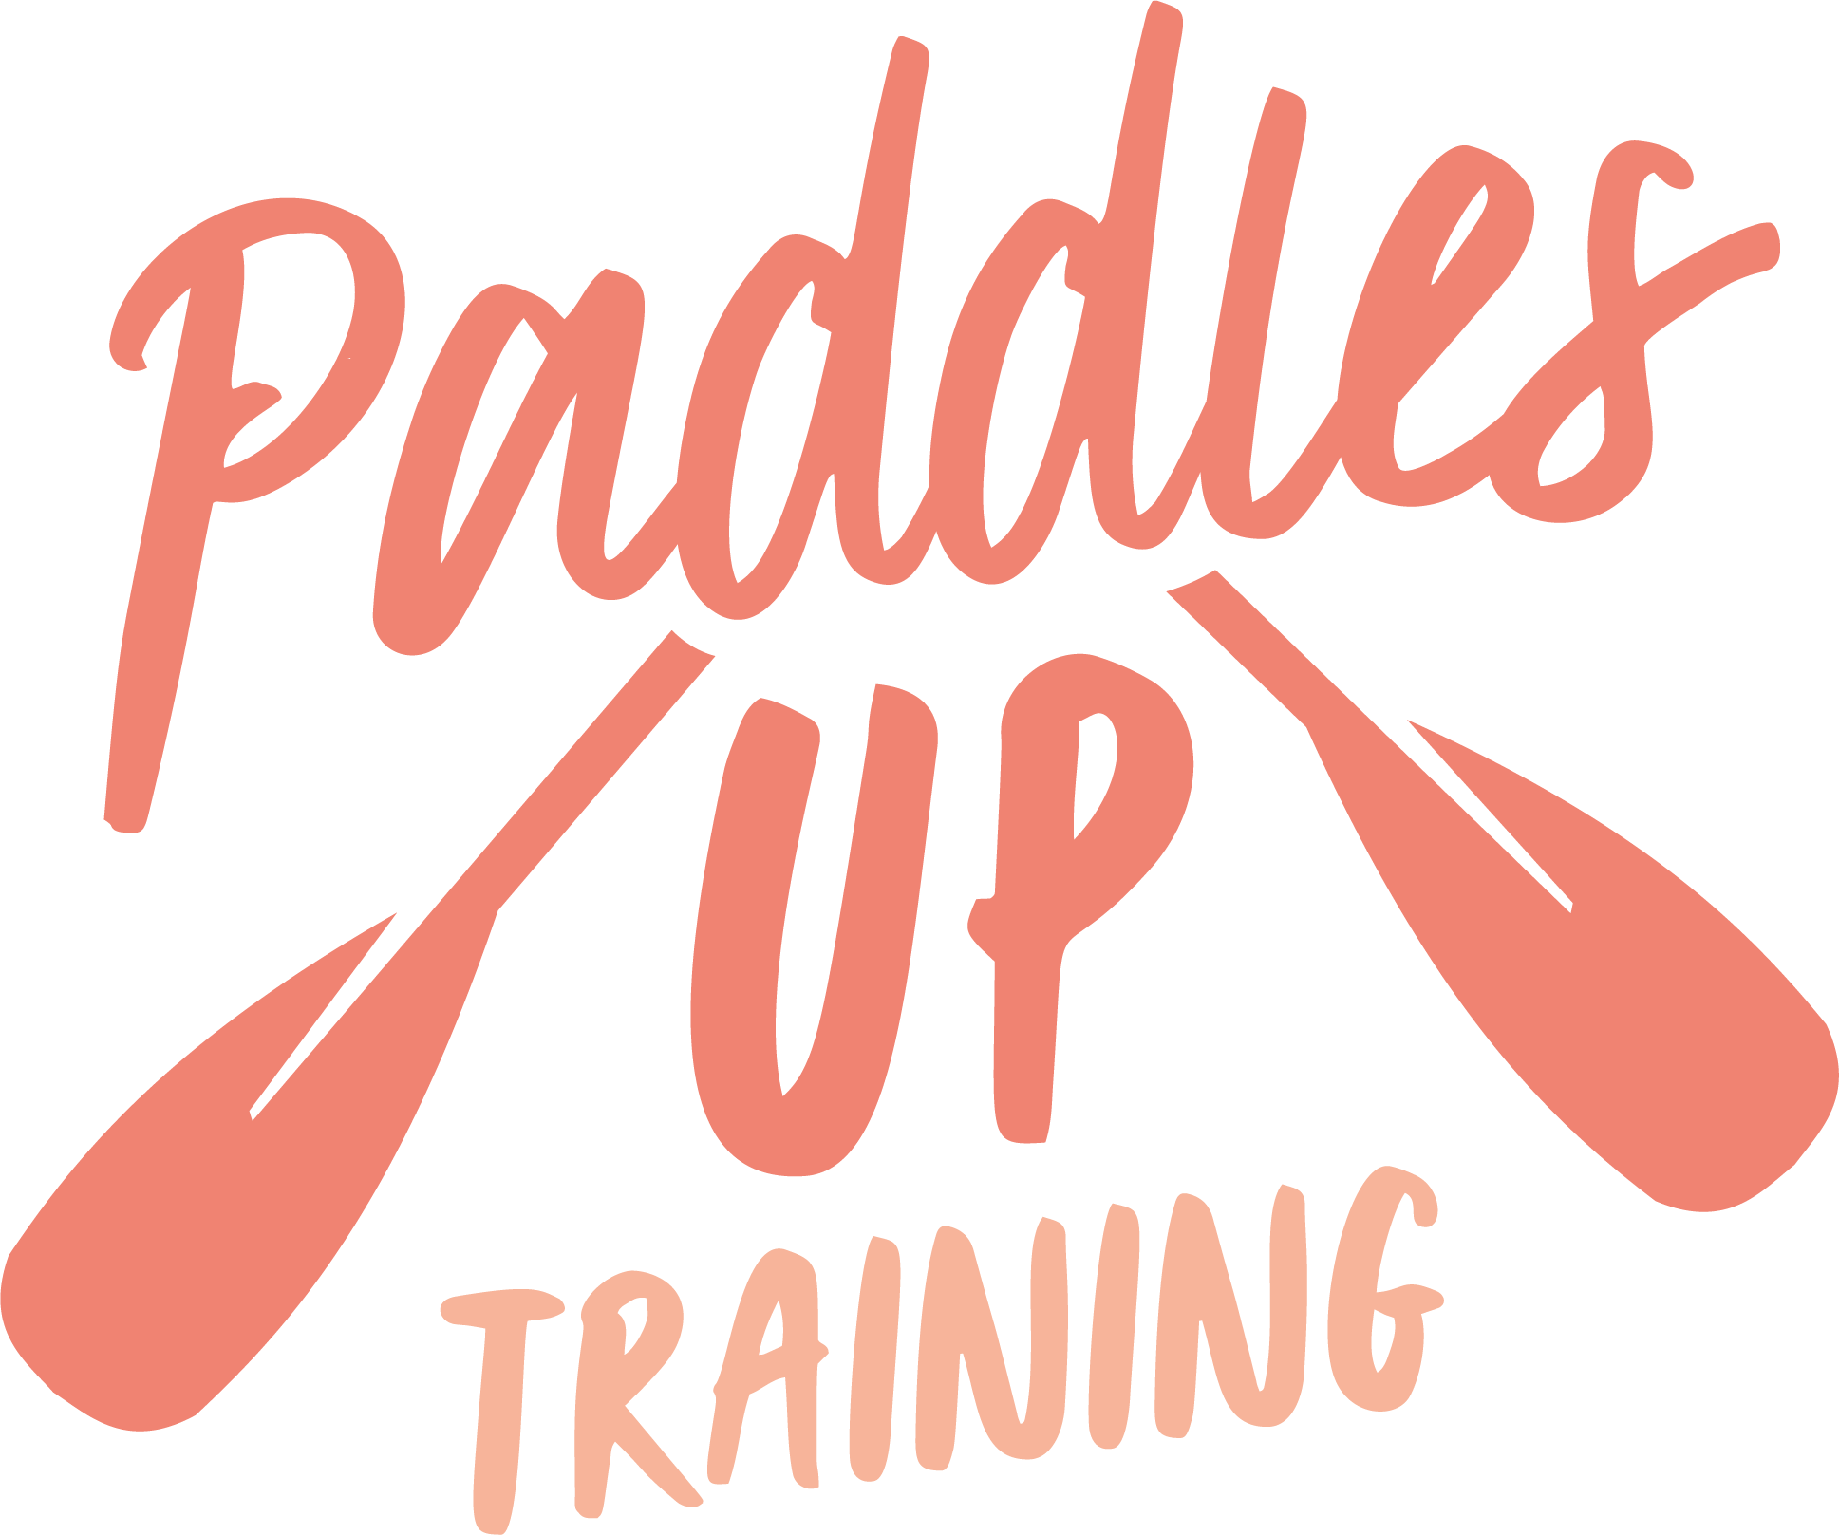

British Canoeing Awarding Body has both a digital library full of useful resources, as well as self-analysis tools for coaches and leaders to aid in your development.
Guidance notes for all Personal Performance, Safety, Coaching and Leadership Awards are found at the British Canoeing Awarding Body Website

Paddling Experience:
Record details of sessions, trips, journeys and expeditions and any other paddlesport experience.

Date | Details | Reflections
dd/mm/yyyy | Insert details about the experience here | Write a short reflection on what you learnt or any developments to consider

Leading Trips, Journeys and Expeditions
Record the trips, journeys and expeditions you have led or assisted on. Having a range of experiences in different locations, weather and people you are leading helps develop skills, knowledge, confidence and experience.
Date | Group Details | Activity | Venue | Conditions | Reflections
dd/mm/yyyy | Number, age, experience | Leading, journey, expedition | Venue name | Weather, water | Write a short reflection on what you learnt or any developments to consider

Instructing/Coaching
Record here courses or sessions that you have either delivered or assisted in the delivery.

Date | Group Details | Activity | Venue | Conditions | Reflections
dd/mm/yyyy | Number, age, experience | Leading, journey, expedition | Venue name | Weather, water | Write a short reflection on what you learnt or any developments to consider

